Term Deposit Subscription Prediction (Bank Marketing) (Report)

1.Introduction and Problem Statement:
Banks conduct marketing campaigns to promote financial products such as term deposits. However, not every customer subscribes to the offered product. Predicting which customers are more likely to subscribe can help banks reduce marketing costs and improve campaign effectiveness.

Objective
The objective of this project is to build a machine learning model that predicts whether a customer will subscribe to a term deposit based on customer information and previous marketing campaign data.
The project also aims to:
- Analyze customer behavior
- Compare classification algorithms
- Evaluate model performance
- Use Explainable AI (SHAP/LIME) for prediction interpretation

2. Dataset Description and Loading:
The dataset used is the Bank Marketing Dataset from the UCI Machine Learning Repository.
It contains customer-related information collected during direct marketing campaigns conducted by a Portuguese banking institution.

Important Features
Feature | Description
age | Customer age
job | Type of job
marital | Marital status
education | Education level
balance | Average yearly balance
housing | Housing loan status
loan | Personal loan status
contact | Communication type
duration | Last contact duration
campaign | Number of contacts during campaign
previous | Number of previous contacts
poutcome | Outcome of previous campaign
y | Target variable (Subscribed or Not)

Dataset Loading
The dataset was loaded using Pandas:
df = pd.read_csv('bank marketing full.csv', sep=';')

3. Data Cleaning and Preprocessing:
Data Cleaning
The dataset was checked for:
- Missing values
- Duplicate records
- Incorrect data types
No major missing values were found in the dataset.
Preprocessing Steps
The following preprocessing techniques were applied:
1. Encoding Categorical Features
Since machine learning models cannot directly understand text values, categorical columns were converted into numerical values using Label Encoding.
Example:
- yes → 1
- no → 0
2. Feature Scaling
Feature scaling was applied using StandardScaler for Logistic Regression because the algorithm performs better when features are normalized.
3. Train-Test Split
The dataset was divided into:
- 80% training data
- 20% testing data
This helps evaluate model performance on unseen data.

4. Exploratory Data Analysis (EDA) with Graphs:
EDA was performed to understand customer patterns and relationships between variables.
Key Analysis Performed
1. Subscription Distribution
A count plot was used to observe how many customers subscribed versus not subscribed.
Observation
Most customers did not subscribe to the term deposit, indicating class imbalance.
2. Age Distribution
Histogram and density plots were used to analyze customer age groups.
Observation
Middle-aged customers were more likely to participate in campaigns.
3. Job Category Analysis
Bar charts showed which job categories subscribed more frequently.
Observation
Management and technician job categories showed higher subscription rates.
4. Balance Analysis
Scatter plots and box plots analyzed customer account balances.
Observation
Customers with higher balances were more likely to subscribe.
5. Correlation Heatmap
A heatmap was created to identify relationships between numerical variables.
Observation
Features such as duration and previous outcomes had stronger influence on subscription prediction.
5. Model Training and Testing:
Two classification models were developed:
1. Logistic Regression
A statistical classification algorithm used for binary classification problems.
Advantages
- Fast
- Simple
- Easy to interpret
2. Random Forest Classifier
An ensemble learning algorithm that combines multiple decision trees.
Advantages
- High accuracy
- Handles non-linear relationships
- Better feature importance analysis
Evaluation Metrics
The models were evaluated using:
1. Confusion Matrix
Shows:
- True Positives
- True Negatives
- False Positives
- False Negatives
It helps understand prediction accuracy in detail.
2. F1-Score
F1-score balances:
- Precision
- Recall
A higher F1-score indicates better classification performance.
3. ROC Curve and AUC Score
ROC Curve measures the model’s ability to distinguish between classes.
Observation
Random Forest achieved better ROC-AUC performance compared to Logistic Regression.
4. Explainable AI (SHAP/LIME)
SHAP values were used to:
- Interpret model predictions
- Identify important features
- Explain customer subscription behavior
Important Influencing Features
- Duration
- Balance
- Age
- Previous campaign outcome
- Contact type
6.Visualization:
Several visualizations were created for better understanding:
Visualization | Purpose
Count Plot | Subscription distribution
Histogram | Age distribution
Box Plot | Balance analysis
Heatmap | Correlation analysis
ROC Curve | Model comparison
Confusion Matrix | Classification accuracy
Feature Importance Graph | Important variables
SHAP Summary Plot | Explainable AI insights
Interactive visualizations were also included in the dashboard using Plotly and Dash.
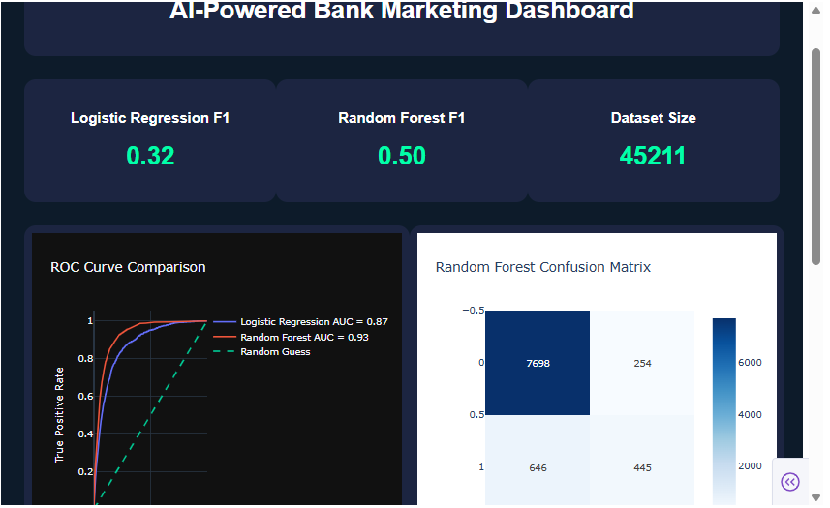
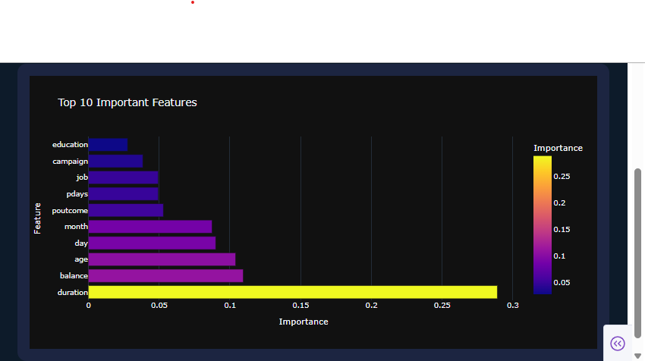

7. Conclusion with Insights:
The project successfully developed machine learning models to predict term deposit subscriptions using customer and campaign data.
Among the tested models:
- Random Forest performed better than Logistic Regression
- SHAP explanations improved model transparency
- Dashboard visualizations enhanced business understanding

Key Insights
- Customers with longer call durations were more likely to subscribe.
- Previous successful marketing outcomes increased future subscription probability.
- Financial status and account balance strongly influenced customer decisions.
- Random Forest provided higher predictive accuracy and better feature interpretation.

Business Impact
This system can help banks:
- Target potential customers more effectively
- Reduce unnecessary marketing costs
- Improve campaign success rates
- Make data-driven business decisions

